Portfolio Project – ATM UML & Code

David Graves
Colorado State University Global
CSC505
Dr. Steven Evans
March 5, 2025

ATM UML and Python Script
As part of the final project, I’ve included Image 1 below as a visual representation of an activity-based UML of an ATM experience. The model shows steps including Card Validation via Pin entry that includes a guard where a card is ejected and returned if a counter is tripped with too many bad entries. If successful, however, the card is accepted, and the user chooses to withdraw money. If the money is available, it is dispersed and if the account balance is $0 the account is closed. All the states above loop back to Idle (Welcome) to reset for the next customer.
Image 1 – ATM UML
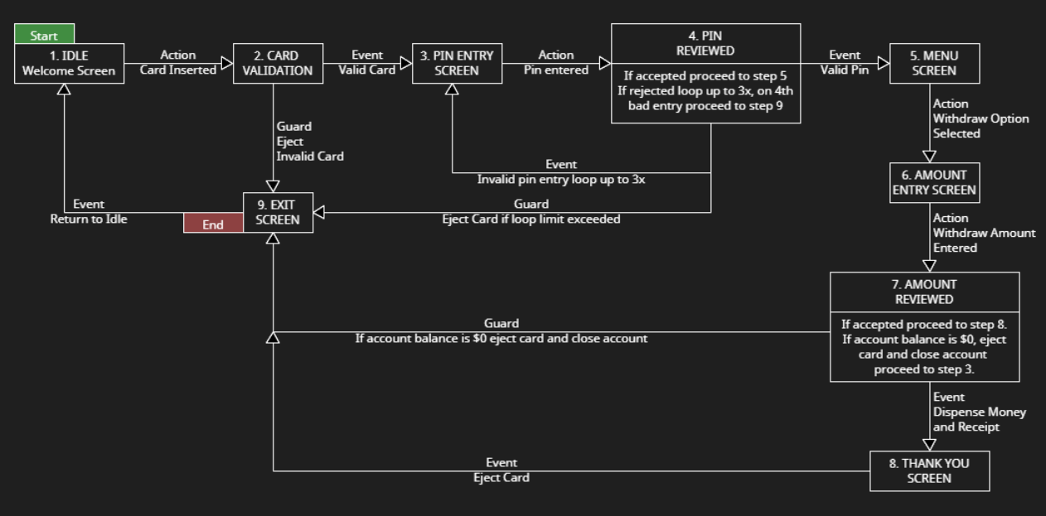
I’ve also written a Python script that will print all the steps in sequence shown in the diagram above. The code is shown below in Image 2 and its successful execution is displayed in Image 3.

Image 2 – Python Script
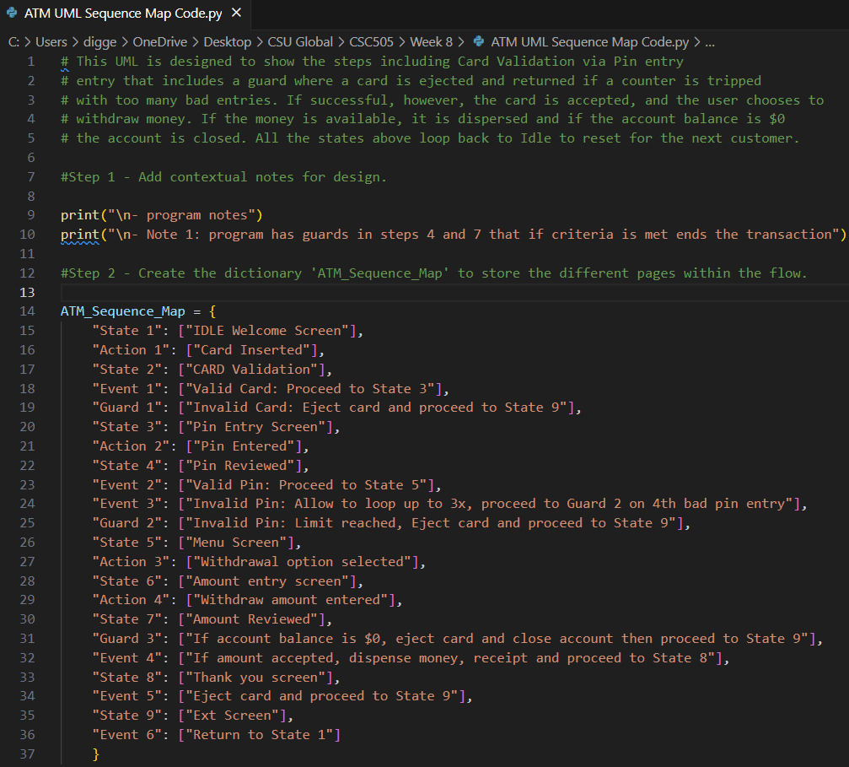
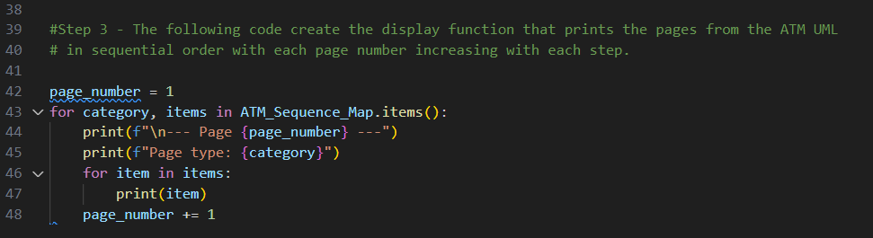

Image 3 – Terminal Output
